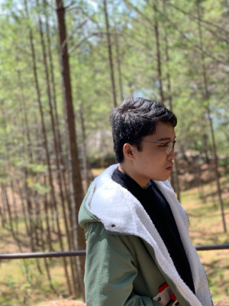 |  | ngo da phu  F&B Attendant
profile  NAME: NGÔ ĐA PHÚ  SEX: MALE  DATE OF BIRTH: 02-10-1995.  ADD: 33/6 Nguyen An Ninh street, ward 14, Binh Thanh District  Ho chi minh city  objective  To become a member in Food & Beverage department, where I can improve my skills and knowledge to benefit growth and success in the future.  Contact  PHONE:  0903782806  EMAIL:  ngodaphutg@gmail.com  Hobbies  Watching movie  Listening music  cooking |  | EDUCATION  Industrial university  2014 – 2017  Hotel & restaurant management  WORK EXPERIENCE  LA VERANDA RESORT – Tran Hung Dao street, Duong Dong town, Phu Quoc island  INTERNSHIP  12-2016 – 3-2017  - Learn how to be a good waiter  - Support full time-staff in restaurant operations.  - Try with all my best to deliver best service for customer  THE MYST HOTEL 4 6 8 Ho Huan Nghiep, Ben Nghe ward, District 1, HCM city  WAITER  9-2017 – 3-2020\  - Greeting and farewell guest with nice performance  - Providing excellent wait service to ensure satisfaction  - Taking order and delivering food and beverages  - Deliver check and collect bill payments  skill  _Basic Barista Art  _Language: English communication  _Computer: Microsoft office  _ Basic Wine knowledge  _ Basic POS machine  _Work under pressure

